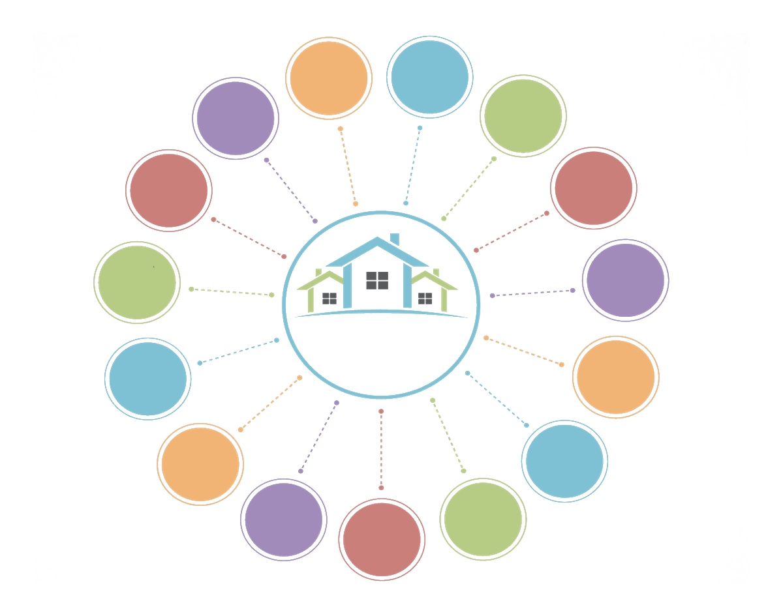
Local Untapped Resources
Linking homeless, people in poverty and at risk to untapped resources
Pro Bono
CPAs
Lawyers
Kiwanis
Rotary
Lions

Pro Bono
Doctors
Dentists

Businesses
JOBS
Paid
Internships
Faith Based
Groups/
Members
Bus Passes
Donated Cars
Phones
Phone service
Housing
Rooms
Basic
Needs
Volunteer
Mentors/
Tutors
Pro Bono
Mental
Health
Food
Clothing
Highly Skilled
Volunteers
Household
Furnishings

